Problem Statement
To design and implement an Autoencoder model that removes noise from images and reconstructs clean images, demonstrating its effectiveness in image denoising tasks.

1. Dataset Source
- MNIST Dataset
https://www.kaggle.com/datasets/oddrationale/mnist-in-csv

2. Dataset Description
- 28×28 grayscale handwritten digits
- 70,000 images
- Pixel values as features
- Target: Clean image reconstruction

3. Mathematical Formulation
- Encoder:
- $h=f(Wx+b)$
- Decoder:
- $\hat{x}=g(W^{'}h+b^{'})$
- Loss:
- $L=∥x-\hat{x}∥^{2}$

4. Algorithm Limitations
- Blurred outputs
- Needs large dataset
- Computationally intensive
🔄 5. Methodology / Workflow
Steps:
- Load dataset
- Normalize images
- Add noise
- Build autoencoder
- Train model
- Reconstruct images
- Evaluate
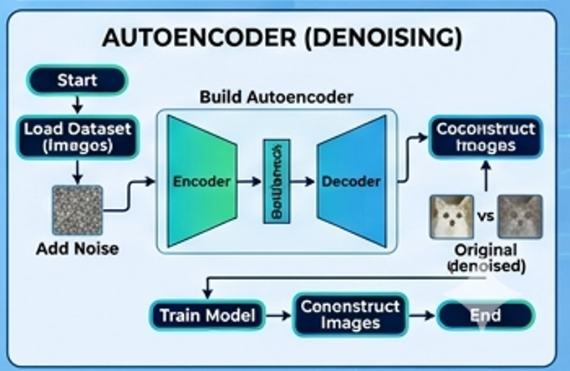

6. Performance Analysis
- Metric: MSE
- Noise significantly reduced
- Output visually cleaner

7. Hyperparameter Tuning
Parameter | Value
Encoding  size | 128
Epochs | 10
Batch size | 256
Noise factor | 0.5
→ Improved reconstruction quality

